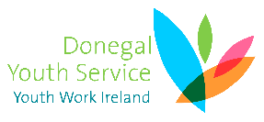Donegal Youth Service Person Specification – Our Generation Youth Worker (Point 4)

Educational  Experience | Essential | A third level education qualification or equivalent in a relevant discipline and a minimum of 5 years community youth work experience in the last 10 years
 | Desirable | A higher degree eg Masters in a related field
Programme Delivery /Facilitation | Essential | Experience in the development and delivery of programmes to children and young people aged 5-25 years in formal and informal settings  Experience in successfully working to the targets/outcomes set out in a specified action plan  Experience of working within a set budget
 | Desirable | Experience in the development and delivery of programmes to children and young people aged 5-25 years in the area of emotional well-being and peace building through integrated community based approaches such as music, art and drama.
Leadership skills | Essential | Proven record of strong leadership skills.
 | Desirable | Proven track record of leadership in the youth/community setting
Communication | Essential | Experience in drafting submissions and annual budget proposals as well as applications  Proven ability to communicate effectively (in both written and oral form) using appropriate technologies
Interpersonal Skills | Essential | Demonstrate good negotiation and interpersonal skills
Other Factors | Essential | Ability to work independently and achieve desired outputs.  Access to own transport and able to meet the travel requirements of the post  Computer literate.

