Job Description
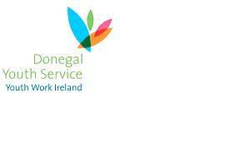

Project: Our Generation

Job Title: Youth Worker

Reports to: Youth Work Manager

Job Summary: To facilitate the delivery of all relevant work packages in relation to the Our Generation Project in line with agreed contractual obligations set out by the Special EU Programmes Body incorporating the Donegal Youth Services youth participation ethos and strength’s-based approach to working with young people.

Responsibilities will include:
Promote the opportunities of the Project, recruit and maintain the necessary number of participants
Facilitate and deliver all necessary training requirements of the Project
Carry out all aspects of programme planning, delivery & evaluation of the Project
Work in partnership with other stakeholders within the Our Generation Project
Developing and maintaining working relationships and partnerships with relevant stakeholders within the sector
Supporting the development and ongoing operation of the cross-border & cross-community Youth Advisory Group
Ensuring that all project targets are being met
Maintain relevant Data as required by SEUPB, organisational and operational

Any other duties shall be such as may be assigned from time to time by the Management Team or by the Board of Directors of Donegal Youth Service

