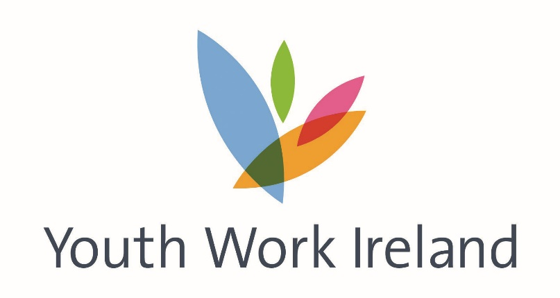

Youth Work Ireland Phased Roadmap Transition Plan

This plan is a national roadmap that best describes the overall service provision plans of Youth Work Ireland Member Youth Services as they transition from Lockdown.

The plan was developed in-line with guidance from the HSE, Government Departments, and with reference to emerging plans within the Department of Children and Youth Affairs.

Youth Work Ireland Member Youth Services have discretion and are ultimately responsible for ensuring the safety of the young people, volunteers, staff, and the communities they serve; and will implement this plan accordingly, with variations as needed.

In some instances, return to face-to-face work may be delayed due to local circumstances. Conversely, face-to-face work may be expedited in some instances if risk assessment identifies safe opportunities to provide essential services to address crises or emergencies.

www.youthworkireland.ie
YOUTH WORK SUPPORTS | PHASE 1  18 May | PHASE 2  8 June | PHASE 3  29 June | PHASE 4  20 July | PHASE 5  10 August | YOUTH WORK OUTCOMES
Crisis/Covid-19 Youth Work Support | Continue to deliver essential services to support young people, i.e. food hampers, support packs (Fun activities, education based, and outcomes focussed materials) & specific crisis response. |  |  |  |  | YP and families receive supports, are connected, and have basic needs met.
Digital Youth Work | Continue to deliver youth work in new ways (e.g. telephone, online, virtual clinics etc, various digital platforms, Kahoot, Facebook messenger, etc.) |  |  |  |  | Youth work supports all 5 BOBF outcomes and connections with young people are maintained.
Youth Chat Service | Continue to deliver new dedicated online youth chat service (Mon-Fri 4-8pm) at present due to funding restrictions) |  |  |  |  | Young people have access to information supports
One-to-One Youth Work | Continue to provide One-to-One youth work using social distancing and provided face-to-face where service has risk assessed a requested intervention from a statutory funder in crisis situations |  |  |  |  | Young people are heard, their needs and interests are identified, and they are supported.
 | Continue to deliver youth work in new ways (e.g. through telephone, online, virtual clinics etc.)
 |  |  |  | One-to-One essential Service for vulnerable/in crises/at risk young people who have not engaged digitally provided
 |  |  |  |  | Phased return of young people to One-to-One work
Home Visits | Continue to maintain contact with parents and young people in new ways (e.g. through telephone, online, virtual clinics etc.) Home visits only to deliver essential services e.g. food packs, etc. |  |  |  |  | Maintain relationships with vulnerable & isolated young people which allow us to connect them with services & supports they need.
 |  |  | Home visit essential service for vulnerable/in crises/at risk young people who have not engaged digitally and only where home visit can take place outside (with social distancing)
 |  |  |  | Home Visit essential Service for vulnerable/in crises/at risk young people who have not engaged digitally only where home visit can take place outside (with social distancing)
 |  |  |  |  | Extend home visit service for young people/ families.
Group Work (<5) | Continue to deliver youth work in new ways (e.g. telephone, online, virtual clinics etc.) various digital platforms, Kahoot, Facebook messenger, etc.) |  |  |  |  | Social connection, group and  collective learning, co-production of knowledge, skills, and social change.  Groups increase the capacity to support members and to achieve their goals, they also enable individual growth and development
 |  |  |  | Risk assess essential small group work (<5) with limited numbers for a limited time (with social distancing. Prioritise vulnerable/in crises/at risk young people who have not engaged digitally (consider use of outdoor facilities)
 |  |  |  |  | Extend group work (<5) to include a larger number of groups for a limited time (with social distancing) -consider use of outdoor facilities
Group Work (5-15) | Continue to deliver youth work in new ways (e.g. through telephone, online, virtual clinics etc..) various digital platforms, Kahoot, Facebook messenger, etc.) |  |  |  |  | Social connection, group and collective learning, co-production of knowledge, skills and social change.  Groups increase the capacity to support members and to achieve their goals, they also enable individual growth and development
 |  |  |  | Risk assess essential youth work (<15) with limited numbers for a limited time (with social distancing)
 |  |  |  |  | Extend youth work (<5) to include larger numbers for a limited time (with social distancing)
Youth Centre – Controlled Access |  |  |  |  | Open MYS Facilities, only where regular and effective cleaning can be carried out and social distancing can be maintained | Venues for organising and providing services allow for more effective programme implementation and increased access to services
Club Work |  |  |  |  | Commence Risk Assessment Planning | Universally available youth services provided at the community level across Ireland
Detached Youthwork and Outreach Work | Online outreach with young people and allied professionals to facilitate contacts with vulnerable young people |  |  |  |  | Young people are brought into an effective relationship with youth workers & connected to supports which address their needs/aspirations
 |  |  | Risk assess detached work where social distancing can be maintained.
 |  |  |  | Commence detached work where social distancing can be maintained
Large Youth Events |  |  |  |  | Commence Risk assessment planning | Large gatherings allow for all young people to have access to unique developmental opportunities
International Youth Work |  |  |  |  | Commence Risk Assessment Planning | Cross-cultural learning, and opportunities of basic, transversal and soft skill development
After Schools |  |  |  |  | Commence Risk Assessment Planning | Children and young people receive educational supports, personal development opportunities and recreational/social services
Community Training Centres | Online classes in progress |  |  |  | Commence Risk Assessment Planning | Young people achieve in formal education within an environment suited to their needs & interests
Counselling | Online provision through therapy hub, Zoom as well as telephone etc |  |  |  |  | Young people receive therapeutic supports, are supported in crises and to address vulnerabilities.
 |  |  |  | Risk assessed face to face for vulnerable/in crises/at risk young people who have not engaged digitally only where social distancing can be maintained
 |  |  |  |  | Commence Risk Assessment Planning

